**Vanier College**

**Faculty of Science and Technology**

**System Development 420-436-VA**

Deliverable 02 + 03

**Grey Team**

Gennaro Finelli

Mohammed Hosein Ali

Alexandre Pham

Wayne De Leon

In collaboration with CyberStation

**(Code from our eCommerce class will be used for certain features of this project)**

**We, the Grey Team, certify that this assignment is our own work**

I, Gennaro Finelli, student ID# 2268107, certify that I have contributed to this deliverable, G.F

I, Mohammed Hosein Ali, student ID# 2055295, certify that I have contributed to this deliverable, M.H.A

I, Alexandre Pham, student ID# 2048017, certify that I have contributed to this deliverable, A.P

I, Wayne De Leon, student ID# 2179710, certify that I have contributed to this deliverable, W.D

Table of Contents

Executive Overview 3

Client/Business 4

Business Domain 4

Business Environment 4

Description of Client 4

Business Problem 4

The Questionnaire 5

References 7

Project Plan 8

# Executive Overview

Cyber Station is a gaming lounge that provides its customers the opportunity to play video games, while being able to be served food and drinks to enhance the experience. It combines the ideas of an arcade with the latest consoles. Cyber Station has a great business environment but can be further developed an added online presence. Cyber Station has some current advertising through Instagram, and other websites that review Cyber Station, however they don’t have a website of their own. The staff is very friendly, and the business has great reviews. Our website will help the client and her staff with the organization of their reservations.

Over the course of this deliverable, we booked a meeting with our client, which happened on the 10th of September. During the meeting we asked our client questions about what she wants on the webpage. We then translated the customer requirements to our user stories.

For deliverable 3 we used Jira in order to help organize all our user stories. The user stories were made based on the answers to the questions we asked our client. We then created a test for each of our user stories, based on our clients’ requirements. Finally, we separated the user stories into their appropriate section in the story map.

# Client/Business

## Business Domain

Cyber Station is a gaming lounge. According to Taryn Hefner, who made a blog on Join It, gaming lounges provide its customers with the opportunity to play video games. It can also include tournaments, cosplay contests, networking events and other events. It combines the idea of an arcade with the latest games and consoles. Certain gaming lounges provide food and drinks to customers to make it more of a hang out spot.

## Business Environment

Cyber Station has a great business environment, but everything can be developed with added online presence which will be done along the process of this project. Currently, Cyber Station has some advertising through the internet in the form of Instagram and other websites that review the platform, but it is missing its own website. Not only does creating its own website boost the business’ online presence but also helps the staff have an easier time doing their job. Reservations of consoles will also aid customers see if a spot is free or reserved so they can manage their time better. The staff is very friendly, and the business has a great review online. In all, the business has a great environment for both the staff and the customers.

## Description of Client

Our client’s name is Sarah Chahrour, she is currently running a gaming lounge located in the airport called, CyberStation, where she provides a gaming station for customers to pass time as they wait for their flights. She offers times for customers to book a gaming station for a set amount of time.

Our client does not have any computer/programming skills. She will not be the only one able to access the project we make; her workers will also have access to view the project we develop.

## Business Problem

Our client has no website for her gaming café business. So, she would like for us to make her a web application so clients can have an overview of her business. In the website, clients will be able to make reservations because clients usually line up in front of the store and don’t know the estimate of when they’ll be able to reserve spot. Additionally, they can also read up more about the business. Also, employees will be able to track reservations and CRUD their status’.

Lastly, the client writes all of her gross sales and cash profit with pen and paper. For that reason, she would like an additional feature to track sales (sales tracker) and automatically calculate the total, etc.

# Closed Questions

1. Will the website be responsive (fits to different types of screens)?

The website will be responsive on all platforms (Ex. Mobile, tablet, laptop).

2. Do you have a style guide?

The style guide was provided by client and will be used properly.

3. What types of logins would you like (website login, Google, etc.)?

Just admin login will be available

4. Do you have a specific art or design idea?

Yes, the design will also be provided by the client templates.

5. Do you want to manually change the time or automatically?

Only admins will be able to manually change the time on the reservation

6. Do you want there to be cancellation fees?

No cancellation fee is required.

7. Do you want merchandise included on the webpage?

No, merchandise will be included other than the reservations.

8. If so, what would you like to include for the product (image, price, stock, etc.)?

No extra products.

9. Do you want employees to access reservations?

No, she only wants admin to be able to access reservations.

10. About Us Page

She wants one that would talk about her company.

11. Types of languages (French, English)

Yes, only French and English.

12. Contact Page

Yes, she wants a contact page with inquiry and hiring options.

13. Home Page

Yes, and she wants it with her own templates and logos that were provided.

14. Reservation Page

Yes, she will need it for her clients and stations.

15. Third party payments? (PayPal, Google Pay, etc.)?

Yes, PayPal and google pay would be included.

16. User Hierarchy (What account type controls which, how many account types: customers, employee, admin, etc.)

She does not want any other accessibility other than her admin roles.

# Open Questions

There were no open questions since the client knew exactly what she wanted. We offered extra services to the client, but she insisted solely on a reservation feature. She provided a website template as well as a color scheme and logos for the website.

# References

Hefner, T. (2022, May 3). *What is a gaming lounge?*. Join It. <https://joinit.com/blog/what-is-a-gaming-lounge#:~:text=It%20can%20also%20include%20tournaments,of%20a%20hang-out%20hub>.

# Project Plan

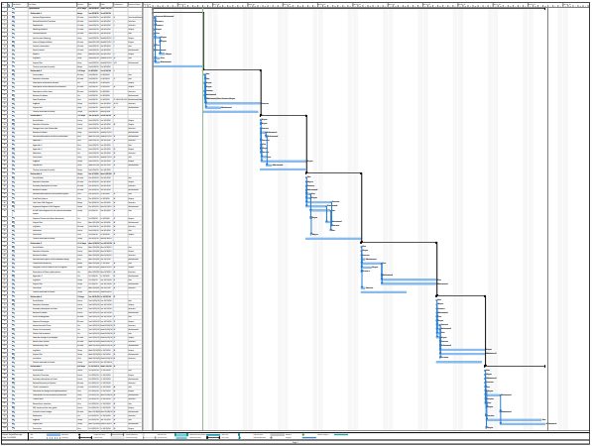

<https://drive.google.com/file/d/1lCVqBy63ZIDcD1_eCIk4fwLjSIlaVcDq/view?usp=sharing>

# Appendix 1

Mohammed, our main contact with our client, Sarah, set up a meeting to discuss what is required for her web application. We made a list of questions that asks our client what kind of features she would need and want for her web application. The user stories we obtained will be for our client only which is an admin.

Product Backlog

# Appendix 2

|  |
| --- |
| Title: Will the website be responsive (fits to different types of screens)? |
| User Story:  As a client or admin  I want to be able to open the website on all platforms, mobile, desktop, laptop.  So that I can access the page whenever wherever. |
| Acceptance criteria:  Given that some people would like to plan a head of time they would like to access the reservation  Without difficulty, as well as have the admin check up on the website if anything were to happen or an update. |

|  |
| --- |
| Title: do you have a Style guide? |
| User Story:  As an admin, they would like to keep the color theme and logos of my own company  So that everything would blend in with each other. |
| Acceptance criteria:  Given that the shop already has a color scheme and logos they expect to stay the same and not go out of subject. |

|  |
| --- |
| Title: What types of logins would you like |
| User Story:  As an Admin,  They would like to be the only user to log in and have accessibility to edit and update the reservations |
| Acceptance criteria:  Given that the user is going to an airport and will not be a regular client there is no need to create a client account and the admin should be able to keep track and fix or edit reservations or menu options |

|  |
| --- |
| Title: Do you have a specific art or design |
| User Story:  As an admin, they had their own logos and art design they want to keep and represent their company with. |
| Acceptance Criteria:  Given that the client has their own design that want to be kept to represent the shop they will provide us with their personal work and design. |

|  |
| --- |
| Title: do you want to manually change the time? |
| User Story:  As an admin,  They would like to make updates on the clients reservation like maybe pause the timer or reset it |
| Acceptance criteria:  When the admin logs in they would like to edit or update their prices or maybe add new items they would also like to edit timers for their clients in case the clients need to step away or wants to pause his timer. |

|  |
| --- |
| Title: About us Page |
| User Story:  As a client,  They would see the backstory and the upcoming of the companies and what is provides so that the clients can understand what is provided. |
| Acceptance criteria:  The admin would like for things to be clear and understanding for the client so with the about us page they would explain the subject and the reasons behind this store. |

|  |
| --- |
| Title: Contact page |
| User Story:  As a client or Admin,  The clients would like to be able to be in contact with the owner for either sponsorships, job interviews, complains or good reviews. |
| Acceptance criteria:  Given that the admin would go to a third party website to be in contact with users they would have their own inbox of data of clients. |

|  |
| --- |
| Title: Home Page |
| User Story:  As a client,  I want to view the Home page,  So that I can see what this gaming lounge is about and what they can offer |
| Acceptance criteria:  Given that the customer is about to access the website, When they click on the website, Then they will be able to access home page. |

|  |
| --- |
| Title: Reservation Page |
| User Story:  As a client,  I want to be able to reserve a seat for my children or for myself to be able to wait for your plane while playing games and enjoying yourself while passing the time. |
| Acceptance criteria:  Given that the client wants to reserve in advance without needing to go to the client and waiting for others to be done for their turn they will be notified when their time will be next. |

|  |
| --- |
| Title: Third Party Payments |
| User Story:  As an Admin, Customer  I want to have third party payments or online payments,  So that I can ensure a spot that I reserved and have an easier and secure way of payment and getting paid. |
| Acceptance Criteria:  Given that the admin and customer will be paid and is paying using third party payments,  When both the admin and customer use it,  Then they will be sure that the payment is done through a secure way. |

# Appendix 3

# Story Map

Part 1:

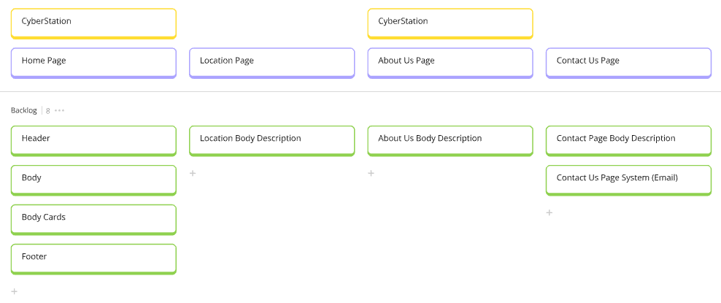

Part 2:

